The code `model = RandomForestRegressor(n_estimators=100, random_state=42)` is used to create an instance of the `RandomForestRegressor` model from the `sklearn.ensemble` module in scikit-learn. This model is used for regression tasks, including time series forecasting. Below is a detailed explanation of the code and its components:

**Random Forest Regressor**

The `RandomForestRegressor` is an ensemble learning method that operates by constructing multiple decision trees during training and outputting the mean prediction of the individual trees. It is particularly useful because it can handle both linear and non-linear relationships in data and tends to be less prone to overfitting compared to individual decision trees.

Parameters in the Code:

1. `n_estimators=100`:

- Meaning: This parameter specifies the number of decision trees in the forest.

- Use: The model will build 100 different decision trees on various subsets of the data, and the final prediction will be the average of all the individual tree predictions. Increasing the number of trees usually improves the performance of the model, but it also increases the computational cost.

2. `random_state=42`:

- Meaning: This parameter ensures reproducibility of the results.

- Use: The `random_state` is a seed used by the random number generator. If you use the same random seed, the model will always produce the same results, which is useful for debugging and consistency across experiments. The number `42` is arbitrary; any integer can be used as a seed.

**How the Model Works:**

1. **Training:**

- During training, the `RandomForestRegressor` creates multiple decision trees. Each tree is trained on a random subset of the training data (both samples and features), a technique known as bootstrap aggregation or bagging. This randomness helps make the model robust and reduces the risk of overfitting.

2. Prediction:

- When making predictions, the model passes the input data through each of the 100 trees and obtains a prediction from each tree. The final output is the average of these predictions. This aggregation of multiple trees helps to smooth out predictions and improves accuracy.

**Use of this Code in Your Project:**

In the context of your project, this line of code is used to define the machine learning model that will be trained on your historical network traffic data. Once the model is trained, it can be used to predict future network traffic or other related metrics. The Random Forest algorithm is a good choice for your project because it can model complex relationships in the data and is less likely to overfit, especially with the ensemble approach of combining multiple trees.

The output of this model, after training, will be the forecasted values of the network traffic or whatever dependent variable you are trying to predict. These predictions can then be evaluated against actual values using the metrics discussed earlier (e.g., RMSE, MAE, etc.) to assess the model's accuracy.

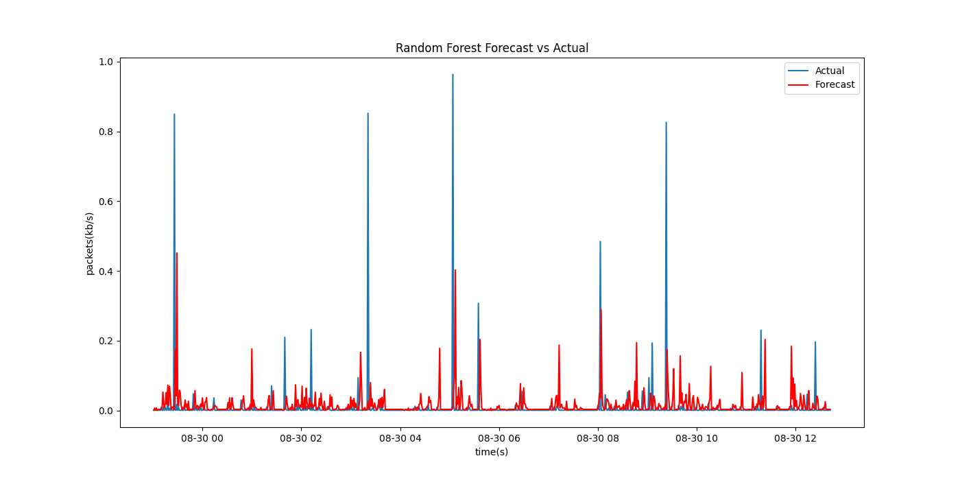

Here are the key points about the graph you provided, comparing the Random Forest Forecast against the Actualnetwork traffic data:

1. **Prediction vs Actual:** The graph compares the actual network traffic (in blue) with the forecasted traffic using a Random Forest model (in red). The actual traffic shows sharp spikes in data usage, while the model's forecast attempts to follow those patterns.

2. **Model Performance:** While the Random Forest model follows the general trend of the actual data, there are some discrepancies, especially during large spikes where the forecast underestimates or does not fully capture the magnitude of the traffic spikes.

3. **Time Range**: The x-axis represents time (in seconds), and the graph covers a specific date (08-30). The y-axis shows the volume of network traffic in terms of packet data rates (kb/s), with spikes representing periods of higher traffic.

4**. Forecasting Behavior**: The forecast generally tracks the lower traffic volume periods well, but it struggles to predict the sharp, high-traffic spikes accurately, indicating that further model refinement may be needed to capture extreme network traffic behaviors effectively.

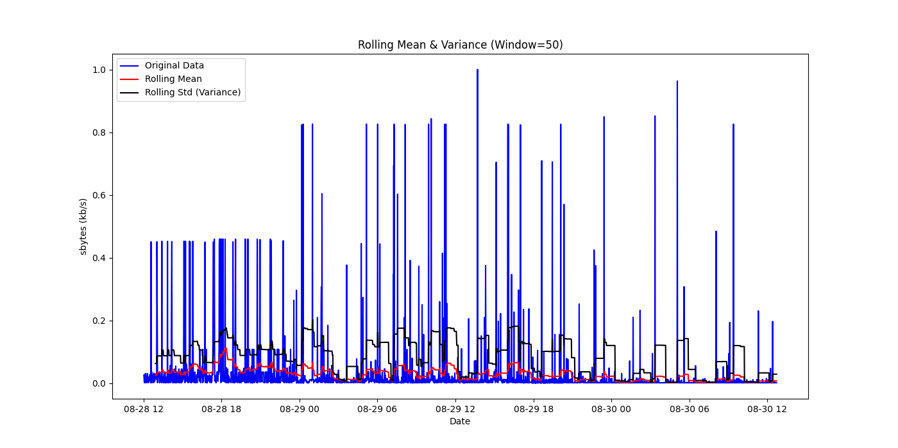

Here are four key points and an explanation of the use of the graph comparing rolling mean and variance for network traffic data:

1. **Rolling Mean & Standard Deviation:** The graph plots the original data (blue line), the rolling mean (red line), and the rolling standard deviation (variance) (black line). The rolling mean and variance are calculated with a window size of 50 data points.

2. **Data Behavior Analysis:** The blue line (original data) shows the raw network traffic data, with sharp spikes representing high traffic moments. The red line (rolling mean) smooths out short-term fluctuations, while the black line (rolling standard deviation) measures the variability within each 50-point window.

3. **Spikes in Traffic**:The original data (blue) shows large, sharp spikes in network traffic at several points. These spikes are not as prominent in the rolling mean and variance, which helps in identifying patterns of consistent traffic behavior versus outliers.

4. **Rolling Window Insights**: The rolling mean indicates the general trend in the data, while the rolling standard deviation helps assess periods of increased variability or stability. Higher rolling variance values (black line) indicate periods where traffic fluctuates more wildly, signaling potential periods of network congestion or anomaly.

**Use of the Graph:**

Stationarity Check: This graph is useful for examining stationarity in time series data. Stationary data would have a constant mean and variance over time. Here, the rolling mean (red) and variance (black) help identify if these metrics are changing over time.

- **Forecasting & Model Input:** Understanding the rolling statistics helps in preprocessing the data for time series forecasting models. If the variance is high, more advanced models (such as LSTM or ARIMA) may be necessary to handle the unpredictability of spikes.

**-Outlier Detection:** The large spikes in the original data (blue line) compared to the relatively smooth rolling mean suggest the presence of outliers, which could be handled separately to improve model accuracy.

Reference:

S.Dong, DD.Zhou, W.Ding. The Study of Network Traffic Identification Based on Machine Learning Algorithm[C]//Fourth International Conference on Computational Intelligence and Communication Networks. IEEE Computer Society, 2012:205-208

[2] BS.Chen, SC.Peng, KC.Wang. Traffic modeling, prediction, and congestion control for high-speed networks: a fuzzy AR approach[J]. IEEE Transactions on Fuzzy Systems, 2000, 8(5): 491-508.

[3] ZY.Tian. Theory and application of time series analysis[M]. Beijing: Higher Education Press, 2003: 214-246.

[4] B. Zou, Q. Liu. Network Traffic Prediction Based on ARMA Model [J]. Computer Research and Development, 2002, (12): 1645-1652.

[5] S. Li, W.Yan, Z.Yan. Prediction of network traffic based on FARIMA model [J]. Computer Engineering and Applications, 2006, 42(29): 148-150.

[6] X.Chen, J.Liu. Improved network traffic prediction algorithm based on wavelet transform and FARIMA model[J]. Correspondence, 2011, 32(4): 153-157.

[7] K. Zhang, Y. Chai, X.Fu. A network traffic prediction model based on recurrent wavelet neural network[C]//Computer Science and Network Technology (ICCSNT), 2012 2nd International Conference on. IEEE, 2012: 1630-1633.

[8] Q. Hua, WT. Ma, JH.Zhao, et al. Prediction method for network traffic based on maximum correntropy criterion[J]. China Communications, 2013, 10(1): 134-145.

[9] Mitchell. Machine Learning[M]. McGraw-Hill, 2003.

[10] ZX.Wang,TZ.Hao Chert,etc a11.Predicting nonlinear network waffle using fuzzy neural network[C].Information, Communications and Signal Processing, 2003 and the Fourth Pacific Rim Conference on Multimtedia.2003,3:1697-1701.

[11] W.Guo, Y.Qiao, H. Hou. BP neural network optimized with PSO algorithm and its application in forecasting[C]//Information Acquisition, 2006 IEEE International Conference on. IEEE, 2006: 617-621.

[12] WT. Zhao, JP. Yin, J. Long. A cognition model of attack prediction in security situation awareness systems. Computer Engineering and Science, 2007,29(11):17−19.

[13] Vapnik VN, Vapnik V. Statistical learning theory[M]. New York: Wiley, 1998.

[14] G.Cheng, J.Gong . Periodic Analysis of Macro-scale Behavior of Large-scale Network Traffic [J]. Small Microcomputer Systems, 2003, 24(6): 991-994.

[15] Z. Li, R.Yuan, and X.Guan, “Accurate classification of the internet traffic based on the svm method,” in Communications, 2007. ICC’07. IEEE International Conference on, pp. 1373–1378, IEEE, 2007

